Manual testing and automation testing

**Manual testing**

**Phase1 : testing concepts – types of testing verification validation**

**Phase2: project work – domain knowledge – find defects – report defected**

**Phase3: Tools - Ajile – jira tool**

**SOFTWARE: IS A SET OF PROGRAMS THAT WILL PERFORM CERTAIN TASK**

Phase1

SDLC (SOFTWARE DEVEOPMENT LIFE CYCLE) PROCCESS WHERE IT BEGINS AND WHERE IT ENDS

**1ST LEVEL:** UNDERSTANDING THE CUSTOMERS REQUIREMENT

**2ND LEVEL:** DESIGN THE SOFTWARE

**3RD LEVEL**: CODE THE SOFTWARE WITH PROGRAMMING LANGUAGES

**4TH LEVEL:** TEST THE SOFTWARE

**5TH LEVEL:** DEPLOY THE SOFTWARE TO CUSTOMER

**TYPES OF SOFTWARE: PROJECT BASE SOFTWARE**

SPECIFIC CUSTOMER REQUIREMENT

**TYPE OF COMPANIES: PRODUCT BASE AND SERVICE BASE COMPANIES**

BASED ON MARKET REQUIREMENT

STLC (SOFTWARE TESTING LIFE CYCLE)

TEST PLANNING

TEST CASE

EXECUTE TEST REPORT

FIND DEFFECTS

FIND DEFFECT REPORT

RE-TEST REPORTS

QA (QUALITY ASSURANCE) & QC (QUALITY CONTROL)

STATIC TESTING AND DYNAMIC TESTING

VERIFICATION VALIDATION

DIFFERENT LEVELS OF SOFTWARE TESTING

WHITE BOX AND BLACK BOX TESTING

FUNCTIONAL AND NON-FUNCTIONAL TESTING

ADHOC TESTING

SANITY & SOMKE TESTING

END-TO-END TESTING

TEST DESIGN TESTING

USE CASE, TESTING SCENARIO & TEST CASES

DEFECT REPORTING

DEFECT TRACKING & DEFECT REPORTING

GENERATING EXCEL REPORT

STATUS REPORT

PREPARING TEST SUMMARY REPORT

PREPARING TEST SUMMARY REPORT AND TEST CLOSURE

PHASE3: AJILE AND JIRA

Phase2: SOFTWARE TESTING PROJECT

REQUIREMENT ANALYSIS (BRS & FRS REVIEWS)

TESTING STATERGY & TESTING PLAN

CREATING TEST SPECIFICATION

TEST SCENARIO PREPERATION

TEST CASE SCENARIO PREPERATION

TEST DATA SCENARIO PREPERATION

PEER REVIEW

REQUIREMENT TRACIBILITY MATRIX

INTRODUCTIONN TO TEST MANAGEMENT & BLOG TRACKING TOOL

BUILD DEPLOYMENT

CONDUCT BUILD ACCEPTENCE TESTING (SANITY)

CONDUCT SYSTEM TESTING

FORMAL TESTING

AD-HOC TESTING

EXPLORATORY TESTING

RE-TESTING

REGRESSION TESTING

END TO END TESTING

DAY 1: I HAVE SPENT 1 HOUR TO LEARN ABOUT THE TESTING WHICH HELPED ME UNDERSTAND THE DIFFERENCE BETWEEN THE PROJECT THAT PRODUCT BASED COMPANIES. SDLC & STLC, UNIT TESTING, INTRIGRATION TESTING, SYSTEM TESTING & UAT TESTING

**SDLC (SOFTWARE DEVEOPMENT LIFE CYCLE) PROCCESS WHERE IT BEGINS AND WHERE IT ENDS**

**1ST LEVEL:** UNDERSTANDING THE CUSTOMERS REQUIREMENT

**2ND LEVEL:** DESIGN THE SOFTWARE

**3RD LEVEL**: CODE THE SOFTWARE WITH PROGRAMMING LANGUAGES

**4TH LEVEL:** TEST THE SOFTWARE

**5TH LEVEL:** DEPLOY THE SOFTWARE TO CUSTOMER

**TYPES OF SOFTWARE: PROJECT BASE SOFTWARE**

SPECIFIC CUSTOMER REQUIREMENT

**TYPE OF COMPANIES: PRODUCT BASE AND SERVICE BASE COMPANIES**

BASED ON MARKET REQUIREMENT

**UNIT TESTING AND INTIGRATION TESTING:** WHITE BOX TESTING IS DEVELOPED BY THE PROGRAMMER WHO KNOWS THE WHAT ARE THE CODING USED TO COMMAND THE SOFTWARE TO RUN.

**SYSTEM TESTING & USER ACCEPTANCE TESTING:** BLACK BOX TESTING FORSOFTWARE TESTERS WHO DON’T NEED TO KNOW WHAT ARE CODES USED TO BUILD THE SOFTWARE BUT NEED TO CHECK WHETHER THE SOFTWARE IS RESPONDING SMOOTHLY WHILE ACCESSING BY THE USER, IF THERE ARE ANY BUGS IDENTIFIED, THE REPORT NEEDS TO BE SENT TO THE CODDING TEAM TO FIND THE SOLUTION FOR THE APPLICATION TO RUN SMOOTHLY.

Day 2:

**SYSTEM REQUIREMENT LIFE CYCLE & V MODULE**

* BRS: BUSINESS REQUIREMENT SPECIFICATION
* CRS: CUSTOMER REQUIREMENT SPECIFICATION
* URS: USER REQUIREMENT SPECIFICATION

**SRS DOCUMENT – IT WILL GIVE US THE INFORMATION ON FUNCTIONALITY APPLICATION CALLED AS SOFTWARE REQUIREMENT SPECIFICATION BASED OON BRS DOCUMENT**

**DESIGNING PHASE – HLD & LLD**

* HLD: HIGH LEVEL DOCUMENS – CONTAINS HIGH LEVEL PICTURE OF THE SOFTWARE, DATAFLOW DIAGRAMS AND ER DIAGRAMS
* LLD: LOW LEVEL DOCUMENTS – IT WILL CONTAIN DELATLED INFORMATIONAL DOCUMENT

**VERIFICATION & VALIDATION GRAPH**

**VERIFICATION: HAPPENS BEFORE THE SOOFTWARE IS DEVELOPED**

**VALIDATION: UNIT TESTING, INTIGRATION TESTING, SYSTEM TESTING & USER ACCEPTENCE TESTING**

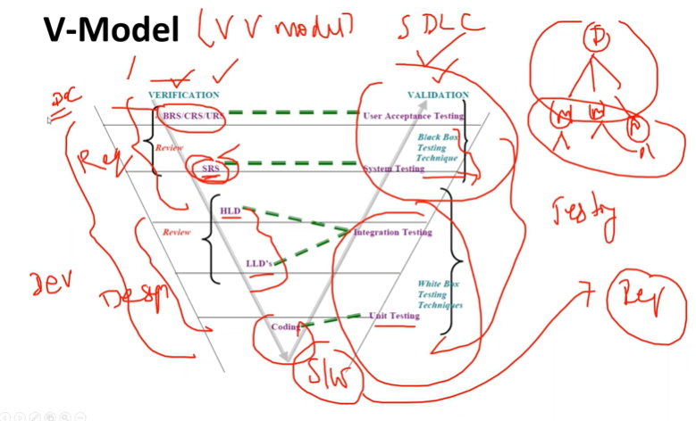

**STATIC TESTING & DYNAMIC TESTING**

**STATIC TESTING: VERIFYING THE DOCUMENT WHETHER THEY ARE CORRECT OOR NOT DONE BY THE DEVELOPER IS STATIC TESTING**

**DYNAMIC TESTING: TESTING THE SOFTWARE DYNAMICALLY WHETHER THE INPUT AND OUTPUT IS PASSING CORRECTLY. UNIT TESTING, INTIGRATION TESTING, SYSTEM TESTING COMES UNDER DYNAMIC TESTING**

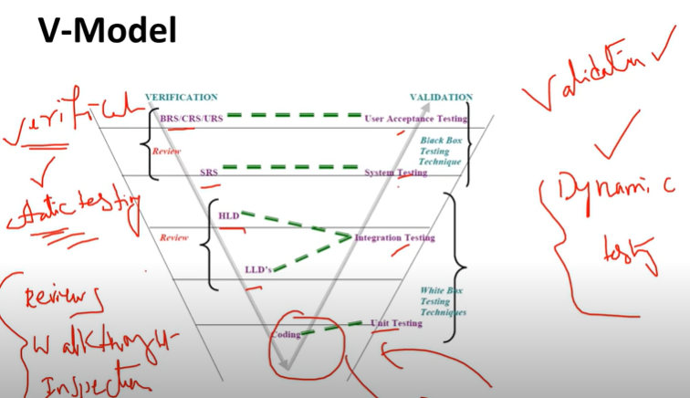

**TYPES OF REVIEW**

**REVIEW: VERIFY WHETHER THE DOCUMENTS IS COMPLETE AND CORRECT**

* REQUIREMENT REVIEW
* DESIGN REVIEW
* CODE REVIEW
* TEST PLAN REVIEWS
* TEST CASE REVIEW

**TYPES OF WALKTHROUGH**

* FORMAL REVIEW THAT INCLUDES THE DISCUSSION TO RAISE THE ISSUE AT THE PEER LEVEL
* IT DOES NOT HAVE ANY SCHEDULE AND IT SHOULD BE DISCUSSED WITHIN THE TEAM

**INSPECTION**

**3 TEAMS WILL BE INVOLVED:**

* **AURTHER (READER):** WHO WILL EXPLAIN THE DOCUMENT, WHAT THEY HAVE MENTIONED IN THE DOCUMENTS
* **WRITER:** WHO WILL WRITE THE COMMENTS PROVIED BY THE TEAM
* **MIDERATOR:** WILL TAKE CARE OF **AURTHER, WRITER, QA, DEVELOPER, PROJECT MANAGEMENT TEAM**

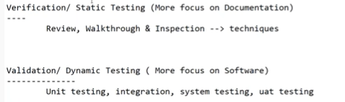

**QA, QC Vs QE**

QA: QUALITY ASSURANCE TEAM WILL DEFINE THE PROCESS START TO END

QC: QUALITY CONTROL WILL CHECK THE IMPLIMENTATION ON THE SOFTWARE PROCESS

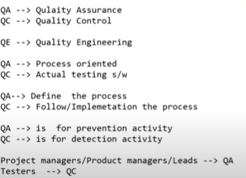

**System testing**

**Understands requirement**

**Write test cases**

**Execute test cases**

**Find defects and report to developers**

**Participate review meeting**

**Write automation script**

**Generate reports**

**Status report send it management**

**Functional testing and non functional testing**

**Day 3:**

**TEST DESIGN TECHNIQUE**

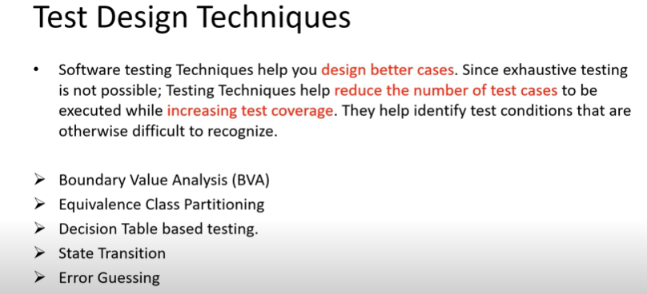

**There are 5 types of test cases**

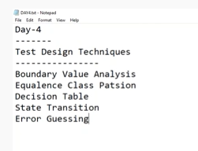

**Testing terminology**

**Sanity testing and smoke testing**

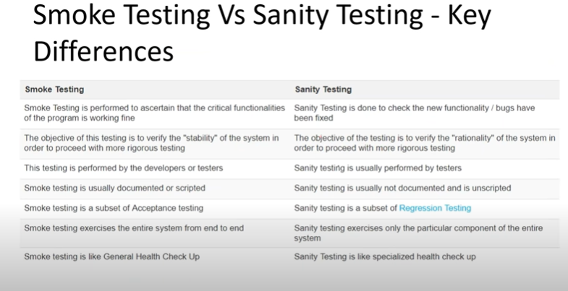

**STLC – software testing life cycle**

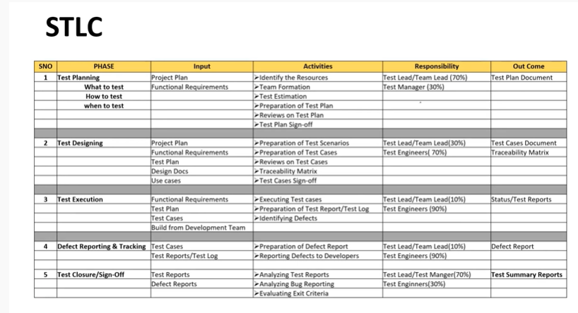

**Test Plan Contents**

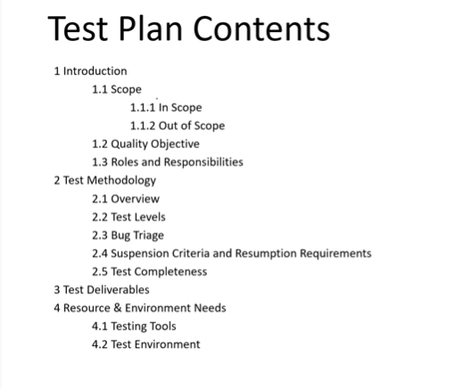

**Used cases test scenario & test cases**

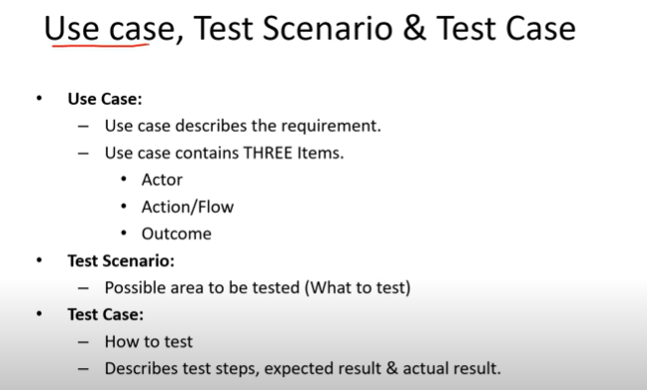

**Used case vs test case**

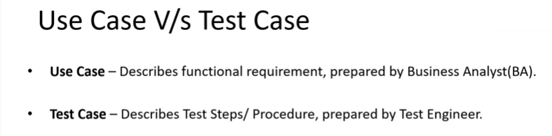

**Test suite**

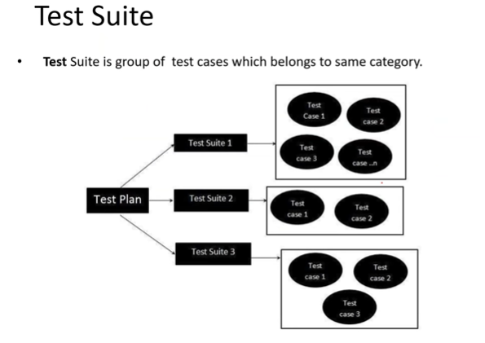

Test case is a set of action to verify the feature or functionality of the software

**Test content**

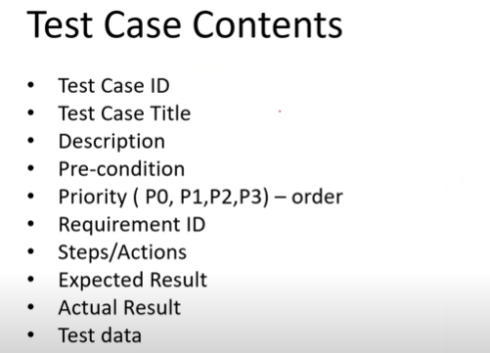

**Test environment**

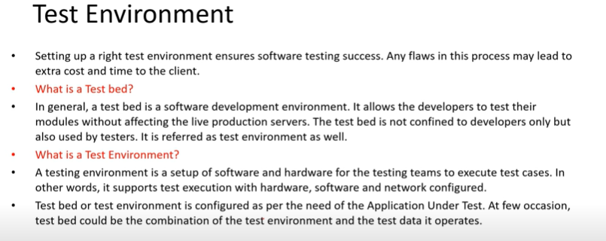

**Defects & Bugs**

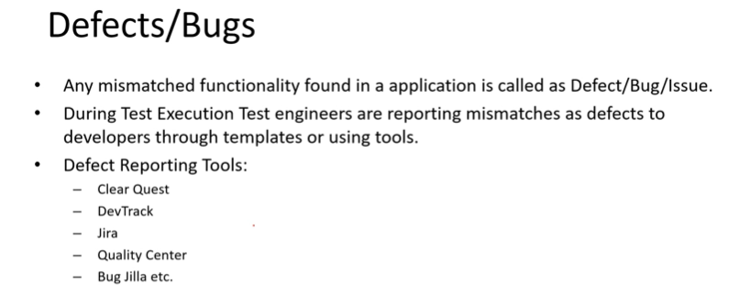

**CSS: Cascading style shade**

**It is for font style, size, button**

**HTML: It is for structure, like a base, header, footer, boxes**

**Source: helps us fetch files like, images, videos saved on the page or website**

**.JS-Java Script: According to client’s requirement, such as what should be the command or functionality means action.**

**Combination of CSS, JS & HTML creates a base of web application.**